**Daniel Williamson**

**Project #4**

**10/3/16**

**CS 212**

**Project Overview:**

After surfing through the many sites I visit. I finally narrowed it down to one site, g2a.com. I choice this site because, it was easy to wright about. There are many things I don’t care for, and there are many things I do like about it.

G2a.com offers a few things. But most importantly it offers game CD keys at a cheap price. Most of these CD keys are from people around their world. Who obtained these keys through various ways like, if someone bought a bundle and didn’t want to key, or maybe they were given the key and didn’t use it. Whichever way they obtained it, they could sell it on g2a.com and make some extra cash. Recently it has been under scrutiny because it is believed that some of the keys were obtained through illegal ways. Although, they have never been charged of any real crime, considering no one could prove if these keys were legally obtained.

Now, one thing to consider, this site was made to sell product. And a lot of people already know what they want. How many times have you searched for games to play without already knowing what you wanted? So, in order to push product for people to even know about it, they have to flash it in front of you. Which brings up a reason why I don’t like the site and we will talk about that more late.

**Front Page:**

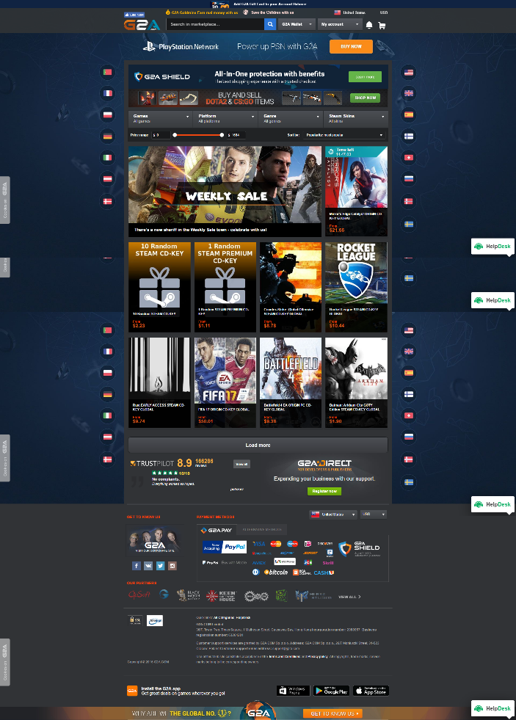

This, is the front page. I used a browser add-on to take a photo of the entire page, and it screws up with absolutely placed elements. So that’s why there are repeats of them. Anyway, the only way to get to this page is through some pop up ads. But once on the site it is actually quite nice looking. I enjoy the dark blue with the darker grey. The colors really match. However, the blue background will change. If you refresh the page, it might become something different. Sometimes it will become a poster for a certain game they are trying to push. But, when it’s the normal background, it is actually quite nice and easy on the eyes. Not so much drama.

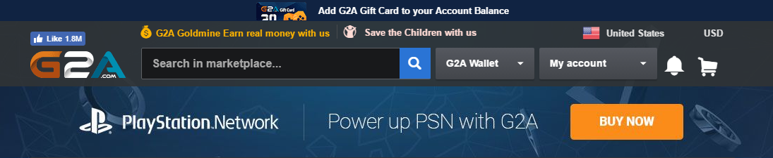

Now if we look towards the top of the page, in the navigation bar. It shows their logo, which is well made. A search bar which gives you the ability to look up any game in their archive. It asks for an account to log in and a message bell. In case you have any pending messages. Also, some links to navigate through their website. Then, it has multiple other buttons. Which I don’t really care for. They are links to spend more money, try and persuade you into buying more. Unnecessary. And annoying.



Next, we will look a bit further down. And the options to spend more money comes up again. They use this space to appeal to the CS: GO and DOTA2 players. Which is huge right now. It’s smart, it’s in a strategic place. It’s where your eyes go. Once again, rather annoying to someone like me. I don’t play either of those games. I’m a consumer who already knows what he wants. Where am I supposed to go?

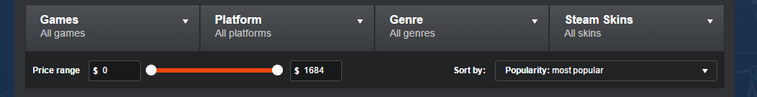

Which leads you to the next few elements. The ability sort through games, platforms, genres and the ever so popular steam skins. It also gives you the chance to pick a pricing range and the ability to sort by options. This is a great spot for someone who wishes to simply just browse games. They can pick whatever price they want, platform and boom! They got all the options they could think of. Thankfully in this part, there is no skim to sell you more product. It’s simple, clean and easy to use.

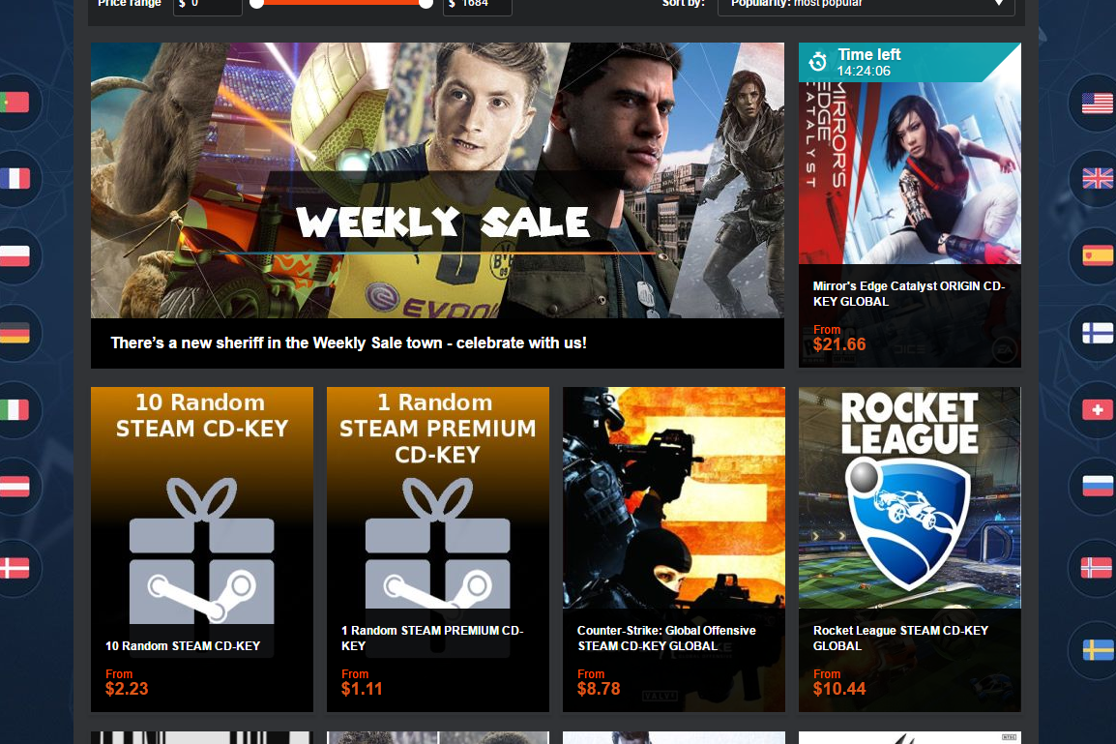

Next, is the body of the website. Another ploy to get you to buy more. This is a place to list their weekly sales. They place big triple A games to get you in. They have a timer to make you feel pressured into buying something. Once again, not something I enjoy. But, perhaps to the consumer who wishes to get a good bargain. The elements look like they are well placed. They look very nice. Keeping the dark grey background. They are all even and look good. While hovering over they become outlined in a red border. They also change the image, giving you a better idea of what you can get. Showing you details about the item.

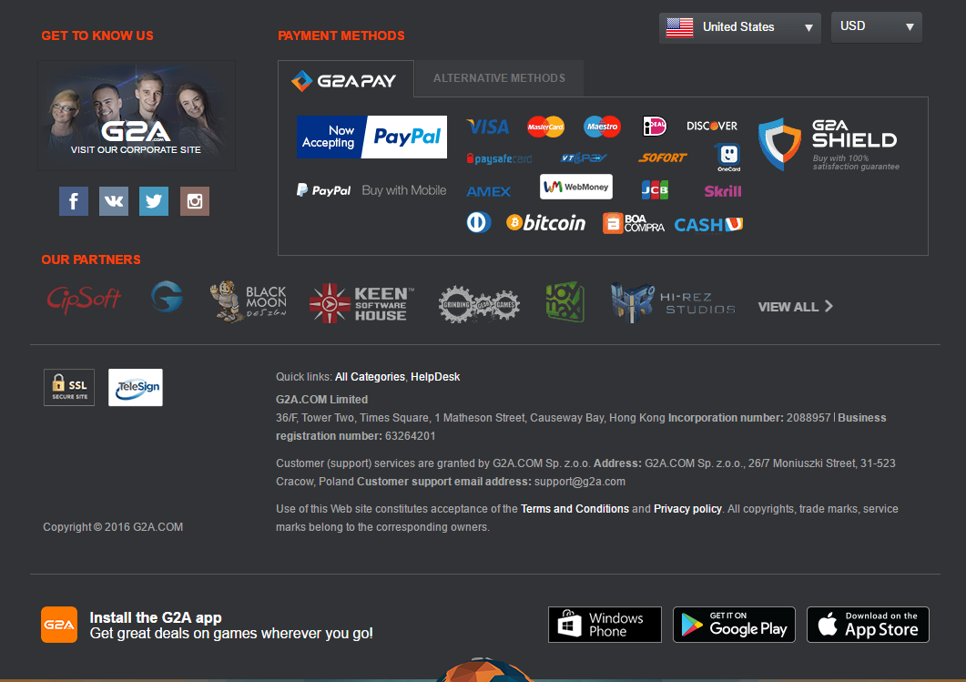

Lastly, they have a fairly large footer. It takes up quite a bit of space. It offers contact information and lets you know how you can pay for their product. It also lets you know their partners. Another opportunity to sell their product. However, all of it, is well placed. It is very easy to read and comprehend.

**Things I’d change:**

There aren’t very many things I’d change. There would only be things I’d take away. For instance, all the elements that want you to buy something. Everywhere you look they just want you to purchase something. Although I do understand why, they are a business. And they need to sell a product. As for the actual look and feel of the site, it is very well laid out. Everything is easy to find. It is all very understandable. There isn’t much that is to confusing or misleading. The color scheme matches, when it’s not a poster background, and just the blue and grey. They have a well-designed logo, and background image. It looks edgy, it looks appropriate for the consumers they are trying to reach.

**Conclusion:**

In conclusion, I believe this is a pretty good site. It is all well placed and looks good. The colors look good especially when the background is simply just the blue. The only things I don’t like, are all the pop ups. Everywhere you look they give you the opportunity to buy a product. I understand that, that is how they need to do it. They need to flash you with the option to buy. If they didn’t I doubt they would be a popular site.